**Coda XL Installation Instructions – For Office 2016**

1. Enter the following URL in an Internet Explorer browser:

<https://usb-sscmpss01.ef.com/CMApplicationCatalog/#/SoftwareLibrary/AppListPageView.xaml>

1. Find the application “Coda XL For Finance Install…” (Version 5.102) and click ‘Install’.

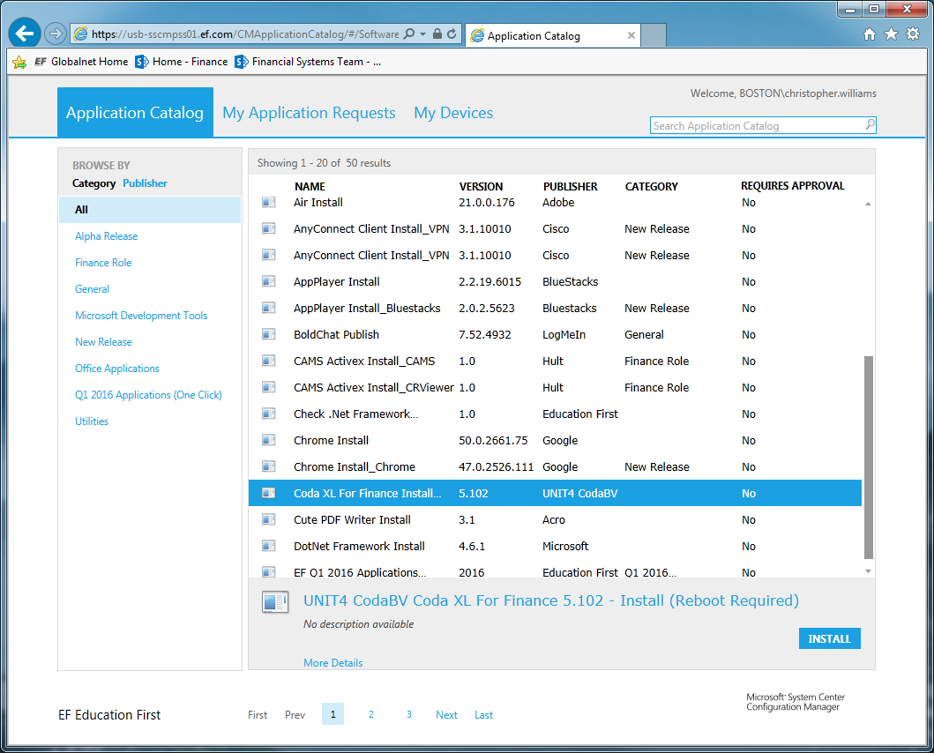

1. Reboot your computer